

ALL FIGURES DOCUMENT
2021 Standards

All Figures Taken From the Self-Study Handbook

based on the
Criteria for Accreditation
Effective Fall 2021

The completed Self-Study Figures and accompanying documents are confidential, and the property of The Commission on Accreditation of Healthcare Management Education (CAHME) and the host University. CAHME requests the agreement of the University to grant access to the Self-Study and accompanying documents to bona fide scholars pursuing projects of potential value to graduate education when specific authority is granted from CAHME.
Table of Contents
REVISION HISTORY 3
Figure 1.A.2.1: Goals Objectives & Performance Outcomes (Example) 4
Figure I.B.2.1: Organizational Chart (placing program within the University) 7
Figure II.A.2.1: Recruitment Activity Outcomes 7
Figure II.A.2.2: Characteristics of Newly Enrolled Students – Criterion II.A.2 7
Figure II.A.2.3: Distribution of Enrolled Students – Criterion II.A.2 7
Figure II.A.2.4: Gender of Graduating Students 8
Figure II.A.2.5: Race and Ethnicity of Graduating Students 8
Figure II.A.5.1: Retention Rate/Time to Graduate Worksheet 9
Figure II.A.5.2: Employment Settings of Program Graduates 10
Figure II.A.5.3: Positions Currently Held by Program Graduates 11
Figure II.A.5.4: Graduate Student Salary 12
Figure III.A.1.1: Competency Coverage across the Curriculum 13
Figure III.A.2.1: Courses Offered in Self-Study Year 14
Figure III.B.1.1: Teaching & Learning Methods - Competency Integration in Health Management Education 15
Figure III.B.3.1: Health Organizations Utilized by Program 16
Figure III.C.1.1 Assessment Methods 16
Figure IV.A.1.1: Summary of Current Program Faculty 18
Figure IV.A.2.1: Faculty by Status 19
Figure IV.A.2.2: Faculty by Full-Time Status 19
Figure IV.A.2.3: Gender of Faculty 19
Figure IV.A.2.4: Race and Ethnicity of Faculty (United States and US Territories only) 20
Figure IV.B.1.1: Listing and Description of Program Research and Scholarship Activity 21
Figure IV.C.1.1: Faculty Pedagogical Development Table Template 21
Figure IV.D.1.1: Description of Faculty Health Related Community Service and Continuing Education Activities (For Self-Study year only) 22
Exporting Figures from CARE 23

REVISION HISTORY
Date | Section | Description
04/07/2025 | Figure I.A.2.1 | Change to Step 2 to remove “required categories”
5/09/2024 | All | Updated Figure Names
 | Instructions for Downloading CAMP Figures | New
2/9/2023 | Cover Page, Rev History & ToC | New
 | Figure 1 | Updated with new table from Self-Study
 | Old Figure 23 | Renamed to Figure 24
 | New Figure 23 | Newly added figure
 | Many figures | Formatting changes

Figure 1.A.2.1: Goals Objectives & Performance Outcomes (Example)
VISION STATEMENT (Reiterate your vision statement from Criterion I.A.1 to ensure goal alignment): The vision of Program X is to be a notable and trustworthy source of knowledgeable, motivated, and highly-trained executive leaders for the healthcare industry.
Completion Guide
- Step 1: Set and understand your program’s mission, vision, and values statements (Criterion I.A.1).
  - See section for Criterion I.A.1.
- Step 2: Set goals designed to achieve your program’s mission and vision.
  - Goals: Goals are statements of ambition that support the overall mission, vision, and value statements of your program by identifying specific areas of emphasis. Goals should align with your vision statement.
    - Example: Educational Goal #1 - To provide outstanding executives to the healthcare industry.
- Step 3: For each goal, set at least one measurable target your program can seek to hit within an academic year.
  - Target: Targets are indicators of successful performance towards the goal. Targets must be actionable and measurable, preferably with a quantitative metric such as a number or percentage.
    - Example: All students will achieve at least an 80% score on the comprehensive core competency exam at the end of their studies.
- Add or delete any rows that are not necessary.
- Candidate programs - Candidate Programs must complete the Goals and Targets to be Met and Measurement Description sections. These sections are shaded in gray. The other sections (in white) are optional for Candidate Programs and will be required in the Self Study
- Self-study year programs - Programs in Self-Study must complete this Figure in its entirety.
Pro-tip: For information on the average number and lengths of goals, see our Core Learning Center (CLC) on our CAHME website.

Example 1:
 | Research Goal #1: Encourage and support innovative research in health economics, health policy, and healthcare administration.
PLAN |  | DO |  | STUDY |  | ACT
Why is this important? How does it align with your mission, vision, values? | Target | Measurement | Date of Assessment | Results | Achieved | Actions Based on Results
 | 100% of faculty will be involved in at least one research effort each academic year | Annual faculty review forms have a designated space to note research efforts currently involved in | 2020-2021 | 100% full-time faculty met this target | Yes | Continue to monitor and assess. Consider hosting a research presentation event for staff members to present to students and the public.
+more

Example 2:
 | Educational Goal #1 - To provide outstanding executives to the healthcare industry
PLAN |  | DO |  | STUDY |  | ACT
Why is this important? How does it align with your mission, vision, values? | Target | Measurement | Date of Assessment | Results | Achieved | Actions Based on Results
 | All students will achieve at least an 80% score on the comprehensive core competency exam at the end of their studies | Score on core competency exam | 2020-2021 | 100% of our students achieved at least an 80% score on the core competency exam | Yes | Continue to monitor and improve.
 | All professors will achieve at least 90% score on didactic core competency knowledge exam | Score on didactic core competency training exam | 2020-2021 | 92% of our professors achieved a score of at least 80% on the didactic core competency training exam | No | Continue to work with professors who did not reach the satisfactory score and improve knowledge of core competencies across faculty members.
 | Add another target here

Figure I.B.2.1: Organizational Chart (placing program within the University)

Figure II.A.2.1: Recruitment Activity Outcomes
Note: Repeat for each degree, or joint degree, Program, as applicable.
Export this figure from CARE (see below Instructions for ‘Exporting Figures from CARE’)
Degree Program: ____________________
Self Study Year: ____________________
 | Academic Year  Start Date:  End Date: | Academic Year  Start Date:  End Date: | Academic Year  Start Date:  End Date:
Complete applications received
Applicants offered admission
Total applicants enrolled (aka new students enrolled)

Figure II.A.2.2: Characteristics of Newly Enrolled Students
Note: Repeat for each degree, or joint degree, Program, as applicable
Export this figure from CARE (see below Instructions for ‘Exporting Figures from CARE’)
Degree Program: ____________________
Self Study Year: ____________________
 | Academic Year  Start Date:  End Date: | Academic Year  Start Date:  End Date: | Academic Year  Start Date:  End Date:
Median Entering GPA of Newly Enrolled Students Only

Figure II.A.2.3: Distribution of Enrolled Students
Export this figure from CARE (see below Instructions for ‘Exporting Figures from CARE’)
Enrolled Students | Degree Program: ____________________  Self Study Year: ____________________
 | Academic Year  Start Date:  End Date: | Academic Year  Start Date:  End Date: | Academic Year  Start Date:  End Date:
Full-Time
Part-Time
TOTAL

Figure II.A.2.4: Gender of Graduating Students
Export this figure from CARE (see below Instructions for ‘Exporting Figures from CARE’)
Degree Program: ____________________
Self Study Year: ____________________
 | Academic Year  Start Date:  End Date: | Academic Year  Start Date:  End Date: | Academic Year  Start Date:  End Date:
Male
Female
Other Gender Identity
Unknown
Total Students

Figure II.A.2.5: Race and Ethnicity of Graduating Students
(Gender, race and ethnicity percentages not applicable to Programs outside of the United States and its Territories)
Export this figure from CARE (see below Instructions for ‘Exporting Figures from CARE’)
Degree Program: ____________________
Self Study Year: ____________________
 |  | Academic Year  Start Date:  End Date: | Academic Year  Start Date:  End Date: | Academic Year  Start Date:  End Date:
Hispanic Students (A)
Non-Hispanic  Students | American Indian or Alaska Native
 | Asian
 | Black or African American
 | Native Hawaiian or Other Pacific Islander:
 | White or Caucasian
 | Other (including more than one races/ethnicities)
 | Unknown Race
 | Sub-total (B)
Unknown Ethnicity (C)
Total Graduating Students (A + B + C)

Figure II.A.5.1: Retention Rate/Time to Graduate Worksheet
Export this figure from CARE (see below Instructions for ‘Exporting Figures from CARE’)
Degree Program: ___________
Self Study Year: ____________
The Retention Rate reflects the percent of students who continued in the program past the “initial period of study”. Programs should define the “initial period of study” as either the first semester, first quarter, or period that reflects approximately 25% of the total course of study.  This measure reflects how well the program keeps students engaged. | Academic Year  Start Date:  End Date: | Academic Year  Start Date:  End Date: | Academic Year  Start Date:  End Date:
Enter the number of enrolled students in the first semester/quarter/ “initial period of study” in question. (a)
Enter the number of enrolled students who were enrolled in (a) who subsequently re-enrolled in the immediately following semester/quarter/period of the time period in question. (b)
Retention rate: This is the percent of students who continued in the second “period of study” after initially enrolling in the “first period of study”. If percentage is less than 80 percent, in any year, comment on the percent of students returning. If improvement is needed, describe the initiatives in place to improve. | % | % | %
The Time to Graduate reflects the variability in the length of time it takes students to graduate in the program. CAHME examines the median (50th percentile) time to graduate and compares it to the outlier (80th percentile). This data enables students to understand how long and how much variation occurs in completing the program.
Enter the median (50th percentile) months to graduate for students in the graduating class of the time period in question. Note that this is NOT the mean or average. (a)
Enter the months to graduate of the student at the 80th percentile in the graduating class of the time period in question. (b)
Comment on the variability in the time to graduate. If improvement is needed, describe the initiatives in place to improve.

Figure II.A.5.2: Employment Settings of Program Graduates
Export this figure from CARE (see below Instructions for ‘Exporting Figures from CARE’)
Degree Program: ____________________
Self Study Year: ____________________
 | Position | Academic Year  Start Date:  End Date: | Academic Year  Start Date:  End Date: | Academic Year  Start Date:  End Date:
 |  | Count | Count | Count
Not Eligible | International student returned home without seeking employment
 | Pursuing other Graduate Degree
 | TOTAL NOT ELIGIBLE/NOT SEEKING TO BE PLACED (A)
Placed Students | Post-Graduate Fellowship
 | Hospital/Health System
 | Physician Practice
 | Military Health System or Veterans Health Administration
 | Governmental agencies (i.e., local, state & federal agencies)
 | Trade Association (e.g., AHA, HFMA, ACHE, Blue Cross/Blue Shield Association)
 | Foundation or Voluntary Agency (e.g., RWJ Foundation, Red Cross)
 | Long-Term Care Facility
 | Home Health Agency
 | Consulting
 | Insurance/HMO
 | Information Technology/Analytics
 | Pharmaceutical/Biotech/Medical Device Company
 | National health organizations (CVS/Aetna, Walgreens, Haven aka Amazon-JP Morgan-Berkshire)
 | Investment banking re: healthcare (merger & acquisition, etc.)
 | Venture Capital or Private Equity
 | Employed outside Healthcare
 | Employed overseas in healthcare (but site is unknown)
 | Other
 | TOTAL PLACED (B)
Not Placed (C)
Unknown (D)
Students Eligible to be Placed (E = B + C + D)
Employment Percentage (B / E)

Figure II.A.5.3: Positions Currently Held by Program Graduates
You may supplement survey data with data from LinkedIn. The total number of graduates in this table should equal the number of graduating students in Figure II.A.5.2, Row E
Export this figure from CARE (see below Instructions for ‘Exporting Figures from CARE’)
Degree Program: ____________________
Self Study Year: ____________________
Positions by Type | Academic Year  Start Date:  End Date: | Academic Year  Start Date:  End Date: | Academic Year  Start Date:  End Date:
Executive Office
(e.g. CEO, President, Chief Medical Officer, Chief Information Officer, Chief Operating Officer, Executive Director, Partner, Owner, etc.)
Other Executive Management
(e.g. Vice President, Senior Vice President, Executive Vice President, Associate Vice President, Other Executive Management, etc.)
Management
(e.g. Director, Manager, Unit Administrator, Practice Manager, etc.)
Administrative Staff
(e.g. Senior Analyst, Senior Consultant, Financial Officer, Information Officer, Analyst, Consultant)
Clinical Staff
(e.g. Registered Nurse, Pharmacist, Physical Therapist, Radiology Technician, etc.)
Physician
Educator / Faculty Member
Fellow / Intern
Other (list)
Unknown
Not Placed
Total Graduates Eligible to be Placed (equals Figure II.A.5.2, Row E)

Figure II.A.5.4: Graduate Student Salary
Report: Programs should report salary data of each graduating class from the respective designated academic year.
Purpose: Income is a key outcomes measure.
Data source: each year’s annual survey of graduating students. Graduates should report estimated annual income to the program. Income includes signing and other bonuses.
Directions: Report salary for Fellowships separately from employed job positions.
Round to whole numbers.
Report the median Income of each Class. Median is the 50th percentile. Do not provide the mean or average.
Export this figure from CARE (see below Instructions for ‘Exporting Figures from CARE’)
Degree Program: ____________________
Self Study Year: ____________________
 | Academic Year  Start Date:  End Date: | Academic Year  Start Date:  End Date: | Academic Year  Start Date:  End Date:
Median Fellowship Income
Number of Reporting Graduates
(Fellowship Income)
Median Job Income
Number of Reporting Graduates
(Jobs Income)

Figure III.A.1.1: Competency Coverage across the Curriculum
Competency  (abridged) | Required Courses (abridged) |  |  |  | Other Requirements
 | HSMP 800 Health Care Organization I | HSMP 815 Health Services Organizational Management. | BIO 701 Design & Analysis of Studies in the Health Sciences Organization I | EPI 710 Principles of Epidemiology | Summer Admin Residency | Professional Development
Domain: Communications & interpersonal effectiveness.
Organizational Behavior Theory |  | 3 |  | 1 | 2
Organizational Management |  | 3 |  |  | 2
Management of Human Resources & Health Professionals | 1 | 2 |  |  | 1 | 1
Domain: Critical thinking, analysis & problem solving
Financial Skills |  |  |  |  | 1
Project Management |  |  |  |  | 1
Domain: Management & leadership
Performance Measurement | 1 |  | 1 |  | 2
Structural Design of Health Care Organizations | 1 | 3 |  | 1 | 2 | 1
Operations Assessment & Improvement | 1 |  |  | 1 | 2
Information Technology Management & Assessment | 1 |  |  |  | 1
Domain: Professionalism & ethics
Health Care Ethics |  | 1 |  |  | 2 | 1
Key: e.g. 1 = Beginning Competency; 2=Basic Competency; 3=Professional Competency (as defined by the program).

Figure III.A.2.1: Courses Offered in Self-Study Year
Describe the typical course of study for full-time and (if different) part-time students in each major degree Program offered.
Year in Program | Session | Course Number & Title | Credits | Instructor(s) | Dept | Student Enrollment Program students (non Program) | Offered:  Online Only (O,)  Traditional (T),  Blended/Hybrid (B)
CORE/REQUIRED COURSES
Year One | Fall | HM503 Healthcare Finance | 3 | L.Garroway | MGMT | 15 (4) | O
ELECTIVES

Figure III.B.1.1: Teaching & Learning Methods - Competency Integration in Health Management Education
Level | Teaching and Learning Method | Definition
Lower | Readings | Students complete assigned readings in textbook , articles, websites, etc.
 | Lecture no media | Professor does most of the talking, without any media support.
 | Lectures with media | Professor does most of the talking, with some sort of media support (e.g. PowerPoint, overheads, video, whiteboards, etc.). Students participate via discussion that is primarily characterized by students asking clarifying questions, etc.
 | Guest Speakers | Individual/panel of experts from the field present to student.
 | Online discussions | Students actively engage in an online discussion, either synchronous or asynchronous, with the professor and with each other. Students can stimulate or respond to discussion.
 | Class Discussions | Students actively engage in open discussion with the professor and with each other. Students can stimulate or respond to discussion.
 | Web-based modules | Interactive learning via CD/DVD/Internet that is more than searching for information or reading websites.
Higher | In-class Presentations | Students formally deliver information to the rest of the class in a well-prepared format that required analysis and preparation.
 | Cases | Students actively engage in analyzing a case study to determine causes, implications, strategies etc. Case analysis is either shared with the class through open and interactive discussion or debate, or students prepare a written case analysis for review and feedback.
 | Team activities | Three or more students collaborate as a group to complete one deliverable.
 | Simulation exercises | Interactive learning in which students’ actions significantly affect how the learning unfolds and the subsequent outcomes of the learning. Simulations may or may not be computer based (e.g. tabletop simulations).
 | External Field Experiences | Students are placed in non-academic applied or real-world work settings and allowed to learn from the work experience, including externships and internships. Learning outcomes are shared in the academic environment and evaluated.
 | Strategic/Consulting Projects | Students actively engage in completing an actual consulting project for a health organization. Alternatively, students complete an assignment that simulates a realistic project in a health organization.
 | Reflective learning | Students complete structured process (e.g. journaling, one-minute response, assessment instruments, weekly reports) to review, understand, analyze, and evaluate their own learning and/or performance. The evaluation should be based on pre-selected criteria. In addition, the assessment could include a comparison of their performance assessment with their peers and/or experts in the field.
Adapted from NCHL (2006): Competency Integration in Health Management Education: A Resource Series for Program Directors and Faculty. Used with permission.

Figure III.B.3.1: Health Organizations Utilized by Program
Organization Name | POC Name and Title | Location | Utilization Purpose

Figure III.C.1.1 Assessment Methods
Level | Assessment Method | Definition
Lower | Pre/Post knowledge or skill testing | Any formal comparative assessment of the student’s knowledge or skills both before and after a learning intervention.
 | Knowledge Based Exams | Any formal exam that evaluates student knowledge attainment.
 | Papers/reports | Student generated written work that is part of the learning process or is the final documentation of learning, including research reports, mid-term and or final papers.
Higher | Observation Checklists | Faculty or student-generated observational assessment of skills or behaviors; could be completed by self, peers, faculty, or other experts etc.
 | Synthesis & Analysis Based Exams | Any formal exam that evaluates student synthesis, analysis and/or evaluation ability.
 | Case review and feedback | Utilization of a predetermined set of variables/criteria to evaluate case analysis work, and to provide effective suggestions/recommendations for improvement.
 | Project review and feedback | Utilization of a predetermined set of variables/criteria to evaluate case analysis work, and to provide effective suggestions/recommendations for improvement.
 | Team effectiveness assessment | Criterion-based observational feedback of student behavior (and possibly work products) in team projects.
 | Journals | Collection of reflective writings, either structured or free form, about a topic.
 | Experiential Report/Portfolios | Collection of evidence, prepared by the student and evaluated by the faculty member, to demonstrate mastery, comprehension, application, and synthesis against a standardized assessment rubric.
 | Reflective Modeling | Standardized techniques to facilitate awareness and evaluation of one’s behavior and to generate plans for improvement, including self, peer, faculty, preceptor or other expert assessment.
 | Class participation | Active monitoring, assessment, and feedback focused on the frequency, consistency, and quality of the student’s participation during face to face and online discussions.
 | Strategic or Consulting Projects | Students actively engage in completing an actual consulting project for a health organization. Alternatively, students complete an assignment that simulates a realistic project in a health organization.
Adapted from NCHL (2006): Competency Integration in Health Management Education: A Resource Series for Program Directors and Faculty. Used with permission.

Figure IV.A.1.1: Summary of Current Program Faculty
Faculty Name  (last, first) | Highest degree  earned & year | Year  appointed to  Program | Qualified  (academic)/ (practitioner) | Faculty(Core)/(Adj) | Program responsibility | Percent of renumeration carried in budget | Courses Taught in Self-Study Year  (# of credits) | Significant Experiences Qualifying the Faculty for Courses Taught
Thomassen, Robert | PhD, 2010 | 2014 | Academic | Core | Teaching =40%  Admin =50%  Research =10%  Service = 0%  Non-Program =0% | 100% | HM 502 Management of Healthcare Organizations (3) | - 4 years as Managing Director, Cardiology Associates of Denver Physician Practice  - Taught organizational management in graduate program at Big State University
 |  |  |  |  |  |  | HM 509 Governance and Ethics in Healthcare (3) | - 8 years COO at Sisters of Health

Figure IV.A.2.1: Faculty by Status
Download this figure from CARE (see below Instructions for Downloading CAMP Images)
Degree Program: ____________________
Self Study Year: ____________________
Status | Academic Year  Start Date:  End Date: | Academic Year  Start Date:  End Date: | Academic Year  Start Date:  End Date:
Professor
Associate Professor
Assistant Professor
Adjunct Faculty
Instructor
Lecturer
Clinical
Total

Figure IV.A.2.2: Faculty by Full-Time Status
Note: Within the CAHME Annual Report Editor (CARE), Full-Time status is defined as Full-Time at the university level, not the program level.
Download this figure from CARE (see below Instructions for Downloading CAMP Images)
Degree Program: ____________________
Self Study Year: ____________________
 | Academic Year  Start Date:  End Date: | Academic Year  Start Date:  End Date: | Academic Year  Start Date:  End Date:
Full Time Faculty
All Other Faculty
Total Faculty

Figure IV.A.2.3: Gender of Faculty
Download this figure from CARE (see below Instructions for Downloading CAMP Images)
Degree Program: ____________________
Self Study Year: ____________________
 | Academic Year  Start Date:  End Date: | Academic Year  Start Date:  End Date: | Academic Year  Start Date:  End Date:
Male
Female
Other Gender Identity
Total Faculty

Figure IV.A.2.4: Race and Ethnicity of Faculty (United States and US Territories only)
Download this figure from CARE (see below Instructions for Downloading CAMP Images)
Degree Program: ____________________
Self Study Year: ____________________
 |  | Academic Year  Start Date:  End Date: | Academic Year  Start Date:  End Date: | Academic Year  Start Date:  End Date:
Hispanic Faculty (A)
Non-Hispanic  Faculty | American Indian or Alaska Native
 | Asian
 | Black or African American
 | Native Hawaiian or Other Pacific Islander:
 | White or Caucasian
 | Two or more races
 | Unknown/Not Reported
 | Sub-total (B)
Unknown Ethnicity (C)
Total Faculty (A + B + C)

Figure IV.B.1.1: Listing and Description of Program Research and Scholarship Activity
(Aggregate Summary for Self-Study Year and Prior Two Years)
Core  Program  Faculty | Competitive Grants & Consulting |  |  |  |  |  | Publications |  |  |  |  | Presentations
 | Grants  Awarded As PI |  | Grants  Awarded with other PI |  | Contracts  awarded |  | Books/chapters  Published | Monographs  published |  | Journal articles  published | Reviews  performed | Paper  Presentations | Invited lectures/ presentations
 | # | $ | # | $ | # | # |  | # | # |  | # | # | #
John Smith
TOTALS

Figure IV.C.1.1: Faculty Pedagogical Development Table Template
(From self study year defined as ______ to ______.)
FACULTY | PLAN |  | DO | STUDY | ACT
Faculty Name | Faculty Goals | Learning opportunities  (trainings, workshops, professional affiliations, research, etc.)  Date | How did faculty apply their learnings to their classroom, community, or healthcare field as a healthcare field educator? | Evaluation Tools | What outcomes are achieved?
Sarah Winston, PhD | Goal #1: To understand the extent to which the COVID-19 pandemic has influenced the role of healthcare management workers | ACHE Congress 3/2023 session on impact of COVID 19.  AUPHA Annual Meeting 6/2023. Session on epidemiological evaluation of disease.  NCHL Conference: Healthcare: managers and the pandemic: how to adapt to the COVID-19 world? 11/2022 | Dr. Winston incorporated her learning by introducing a new section in her syllabus dedicated to discussing COVID-19, the history of pandemics, and how to deal with them as healthcare managers. | Knowledge Assessment score from LMS tests | Knowledge scores of students on COVID-19 increased 35%
 | Goal #2: Stay up to date on new healthcare software used by hospitals and private practices | HIMSS 2021: Healthcare software: what is on the horizon in 2023? 7/2022 | Dedicated a class session with an outside speaker to discuss different software that students may need to use in future positions at healthcare settings | Student Assigned Coursework | Student paper of the software tools they would use in the position that they have set as a goal.
Faculty #2
Faculty #3

Figure IV.D.1.1: Description of Faculty Health Related Community Service and Continuing Education Activities (For Self-Study year only)

Faculty | Health Related Community Service Activities | Professional Affiliations / Continuing Education

Exporting Figures from CARE
Note: In lieu of manual completion of figures related to II.A and IV.A.2, programs are encouraged to export the figures from CARE and attach as an Evidence file within CAMP.
If completing manually, the academic years shown must include the current year, the Self-Study year, and the year prior to the Self-Study year.
- Navigate and log in to CAHME Annual Report Editor (CARE): https://cahme.org/_pdlogin/
- In the header section at the top of the page, select the ‘CAMP: Download Figures for Self-Study Evidence Files’ button.
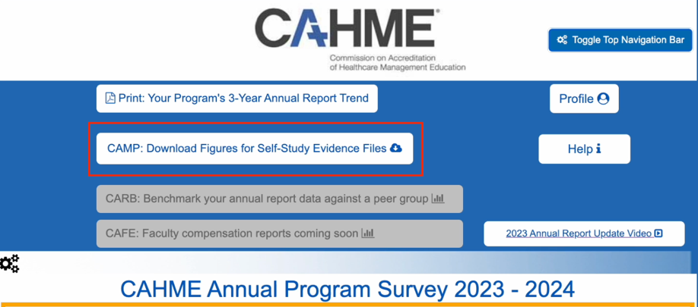
- Enter the program’s Self-Study year to appear on all Figures
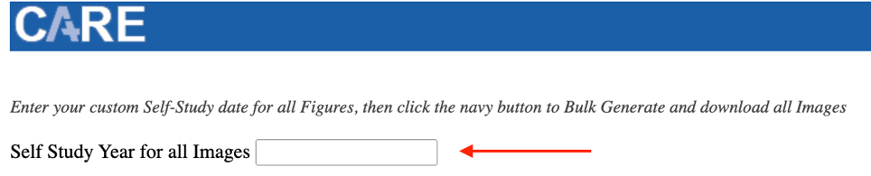
- Then download images in one of three ways:
  - All at once with a bulk download*
  - Per Standard
  - Individually
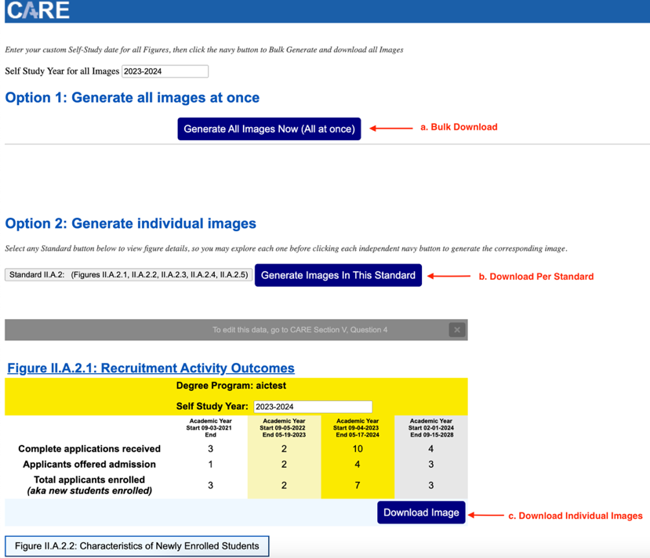
*Note:If Generating All Images at once, then browser settings may need changed to allow bulk downloads for https://care.cahme.org.
- Figures can then be “drag and dropped” or uploaded into the Evidence section of a standard within CAMP
