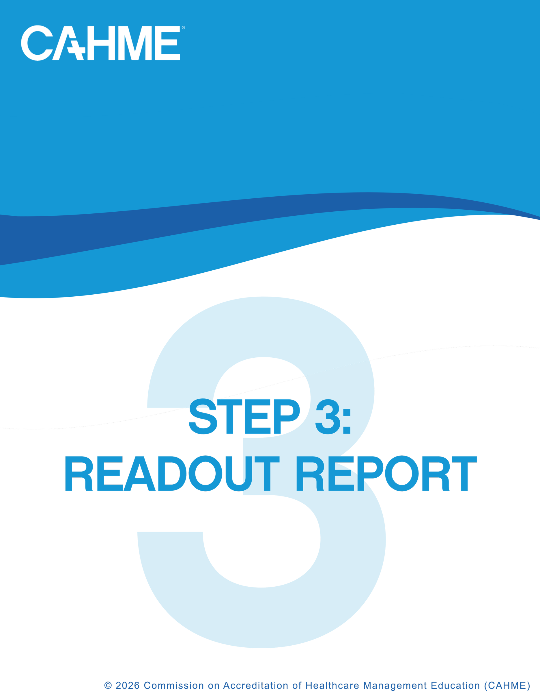

Table of contents
Instructions 3
Introductory Read Out 4
Standard 1: Program Development, Operations And Sustainment 5
Standard 2: Competency Model 7
Standard 3: Curriculum 8
Standard 4: Student Success 10
Standard 5: Faculty 12
Next Steps: What Should The Program Expect Now That The Site Visit Is Complete? 13
Weave Report Creation 14

Instructions
How to complete the Readout Report:
- Select the criterion rating from the dropdown box
- Select the required element rating from the dropdown box
- If required element had finding(s), list the finding(s) and associated action(s) to achieve met as found in Step 2: Findings Database.
- The program will have entered any self-identified strengths for review by the site visit team in the STR criterion in Weave. If the site visit team deems a strength, they should list that strength on the criterion that contains the strength, not on the STR criterion.

How to read the report:
- Introductions: Chair begins with the introduction of the site visit team
- Chair reads the report – not a discussion
  - Read all criteria that were found to have opportunities for improvement and critical concerns
  - Identify required elements that were found to have opportunities for improvement and criterial concerns. Read the actions to achieve met for the required elements.
  - “Met” criteria – not required, if the program feels it will help then do so
  - Read strength(s)
- Audience: Anyone the program wishes – encourage program, college, and university leadership, faculty and stakeholders to attend.

Introductory Read Out
Share the following:
- Good afternoon and thank you for taking the time to join us today. On behalf of the Site Visit Team, I would like to express our sincere appreciation to the program, college, and university leadership, faculty, staff, students, alumni, employers, and advisory board members who contributed to this visit.
- We recognize that accreditation is a voluntary process requiring a significant investment of time, preparation, and reflection. Your willingness to engage in this process demonstrates a strong commitment to educational excellence, continuous quality improvement, and ensuring that graduates are prepared with the knowledge, competencies, and employability skills needed to succeed as future healthcare management leaders.
- We also want to thank you for the exceptional hospitality you have extended to our team throughout the visit. Equally important, we appreciate the openness, honesty, and transparency shown in your self-study, interviews, and discussions. Those conversations enabled us to gain a meaningful understanding of your program, celebrate your accomplishments, and identify opportunities to further strengthen student learning and program quality.
- Yesterday afternoon, the Site Visit Team met to thoughtfully discuss our observations, identify themes, brainstorm ideas, and share resources and promising practices that may be helpful to your program. Earlier today, we met with program leadership to provide detailed feedback and engage in a collegial discussion regarding our observations and opportunities for continued growth.
- The purpose of today's session is to summarize the team's findings for the broader audience. We appreciate your engagement and professionalism throughout this process and thank you for your partnership and commitment to preparing the next generation of healthcare management leaders.
Items to customize for this visit:
- Talk about students and impressions of the team.
- Thank the team members, a voluntary effort for their time and commitment to the process.
- Other – anything else the team wants to share

Findings:
The site visit team assessed Enter Program Name to determine its ability to meet the 18 CAHME criteria.
Each criterion was assessed as Met, Opportunity for Improvement, or Critical Concern.
As a result of the assessment, the team identified:
- Enter # of Met criteria CAHME criteria receiving the Met status,
- Enter # of OFI criteria CAHME criteria receiving the Opportunity for Improvement status, and
- Enter # of CC criteria CAHME criteria receiving the Critical Concern status.

Standard 1: Program Development, Operations and Sustainment
1.1 Mission, Vision, Values
The program will have statements of mission, vision, and values and demonstrate they guide the program’s design, evaluation of effectiveness, and strategic initiatives.
Overall Criterion Rating: |  |  |  | Not Yet Rated
Rating, Finding and Action to Achieve Met by Required Element
Required Element Rating |  |  |  | Finding (Do not read) | Action To Achieve Met
a. | Not Yet Rated
b. | Not Yet Rated
c. | Not Yet Rated
Strength:
1.2 Mission, Vision, Values
The program will have the resources necessary to meet its mission and vision. The program will develop, implement, monitor and maintain a sustainment plan that outlines how the program will preserve its operational capacity, infrastructure, and essential functions over at least a three-year period (self-study year and the following two academic years). The plan will be reviewed and updated on a timeline prescribed by the program.
Overall Criterion Rating: |  |  |  | Not Yet Rated
Rating, Finding and Action to Achieve Met by Required Element (RE)
Required Element Rating |  |  |  | Finding (Do not read) | Action to Achieve Met
a. | Not Yet Rated
b. | Not Yet Rated
c. | Not Yet Rated
d. | Not Yet Rated
e. | Not Yet Rated
f. | Not Yet Rated
Strength:
1.3 Program Leadership and Faculty Authority
Program leadership, faculty, and other stakeholders will have the necessary input in all areas that fulfill the program’s mission, vision, and sustainment plan.
Overall Criterion Rating: |  |  |  | Not Yet Rated
Rating, Finding and Action to Achieve Met by Required Element (RE)
Required Element Rating |  |  |  | Finding (Do not read) | Action to Achieve Met
a. | Not Yet Rated
b. | Not Yet Rated
Strength:
1.4 Student Recruitment, Admissions, Retention
The program will develop, implement, monitor and evaluate a plan for recruitment, admissions processes, and retention of students.
Overall Criterion Rating: |  |  |  | Not Yet Rated
Required Element Rating |  |  |  | Finding (Do not read) | Action to Achieve Met
a. | Not Yet Rated
b. | Not Yet Rated
c. | Not Yet Rated
d. | Not Yet Rated
Strength:
1.5 Information Transparency
The program will ensure students and stakeholders have website access to accurate information about the program's admission and selection criteria, competency model, curriculum and curriculum sequencing, target student population, student success outcomes, stakeholder engagement with program and students, student professional development activities, and post-graduate employment outcomes.
Overall Criterion Rating: |  |  |  | Not Yet Rated
Required Element Rating |  |  |  | Finding (Do not read) | Action to Achieve Met
a. | Not Yet Rated
b. | Not Yet Rated
Strength:

Standard 2: Competency Model
2.1 Competency Model Development
The program will develop, adopt, or adapt and implement a competency model that is industry relevant and prepares students for post graduate employment outcomes.
Overall Criterion Rating: |  |  | Not Yet Rated
Rating, Finding and Action to Achieve Met by Required Element
Required Element Rating |  |  | Finding (Do not read) | Action To Achieve Met
a. | Not Yet Rated
b. | Not Yet Rated
c. | Not Yet Rated
d. | Not Yet Rated
Strength:
2.2 Competency Model Effectiveness
The program measures student competency attainment at the program level.
Overall Criterion Rating: |  |  | Not Yet Rated
Rating, Finding and Action to Achieve Met by Required Element (RE)
Required Element Rating |  |  | Finding (Do not read) | Action to Achieve Met
a. | Not Yet Rated
b. | Not Yet Rated
c. | Not Yet Rated
d. | Not Yet Rated
e. | Not Yet Rated
f. | Not Yet Rated
g. | Not Yet Rated
h. | Not Yet Rated
Strength:
2.3 Competency Model CQI
The program will develop and implement a plan to improve competency model effectiveness.
Overall Criterion Rating: |  |  | Not Yet Rated
Rating, Finding and Action to Achieve Met by Required Element (RE)
Required Element Rating |  |  | Finding (Do not read) | Action to Achieve Met
a. | Not Yet Rated
b. | Not Yet Rated
c. | Not Yet Rated
d. | Not Yet Rated
Strength:

Standard 3: Curriculum
3.1 Graduate-Level Curriculum Development
The program will develop and deliver an industry-relevant curriculum that reflects graduate-level rigor appropriate for the professional and academic preparation of the target audience and prepares students for program-level culminating integrative assessments (see 3.2) and post-graduate employment outcomes. The curriculum will also provide opportunities for students to engage in teams and collaborate with a variety of healthcare professionals, with faculty and appropriate stakeholders involved throughout the process.
Overall Criterion Rating: |  |  | Not Yet Rated
Rating, Finding and Action to Achieve Met by Required Element
Required Element Rating |  |  | Finding (Do not read) | Action To Achieve Met
a. | Not Yet Rated
b. | Not Yet Rated
c. | Not Yet Rated
d. | Not Yet Rated
e. | Not Yet Rated
f. | Not Yet Rated
g. | Not Yet Rated
h. | Not Yet Rated
i. | Not Yet Rated
j. | Not Yet Rated
Strength:
3.2 Program-Level Final Integrative Assessment Development
The program will provide program-level final integrative assessments that demonstrate students achieved the program-level competency proficiency targets.
Overall Criterion Rating: |  |  | Not Yet Rated
Rating, Finding and Action to Achieve Met by Required Element (RE)
Required Element Rating |  |  | Finding (Do not read) | Action to Achieve Met
a. | Not Yet Rated
b. | Not Yet Rated
c. | Not Yet Rated
d. | Not Yet Rated
Strength:
3.3 Curriculum Effectiveness
The program will evaluate the effectiveness of the curriculum and the final integrative assessment(s).
Overall Criterion Rating: |  |  | Not Yet Rated
Rating, Finding and Action to Achieve Met by Required Element (RE)
Required Element Rating |  |  | Finding (Do not read) | Action to Achieve Met
a. | Not Yet Rated
b. | Not Yet Rated
c. | Not Yet Rated
Strength:
3.4 Curriculum CQI
The program will develop and implement a plan to improve curriculum effectiveness.
Overall Criterion Rating: |  |  | Not Yet Rated
Rating, Finding and Action to Achieve Met by Required Element (RE)
Required Element Rating |  |  | Finding (Do not read) | Action to Achieve Met
a. | Not Yet Rated
b. | Not Yet Rated
c. | Not Yet Rated
d. | Not Yet Rated
Strength:

Standard 4: Student Success
4.1 Academic Resources
The College, University, school, and program will offer comprehensive, well-communicated student academic resources including technology resources.
Overall Criterion Rating: |  |  | Not Yet Rated
Rating, Finding and Action to Achieve Met by Required Element
Required Element Rating |  |  | Finding (Do not read) | Action To Achieve Met
a. | Not Yet Rated
b. | Not Yet Rated
c. | Not Yet Rated
d. | Not Yet Rated
e. | Not Yet Rated
Strength:
4.2 Academic Advising
The program will offer or provide access to academic advising resources for all students.
Overall Criterion Rating: |  |  | Not Yet Rated
Rating, Finding and Action to Achieve Met by Required Element (RE)
Required Element Rating |  |  | Finding (Do not read) | Action to Achieve Met
a. | Not Yet Rated
b. | Not Yet Rated
c. | Not Yet Rated
d. | Not Yet Rated
e. | Not Yet Rated
Strength:
4.3 Professional Career Advising
The program will offer or provide access to professional career advising services for all students.
Overall Criterion Rating: |  |  | Not Yet Rated
Rating, Finding and Action to Achieve Met by Required Element (RE)
Required Element Rating |  |  | Finding (Do not read) | Action to Achieve Met
a. | Not Yet Rated
b. | Not Yet Rated
c. | Not Yet Rated
d. | Not Yet Rated
e. | Not Yet Rated
Strength:
4.4 Post-Graduate Career Preparedness
The program will develop and implement a plan to monitor post-graduate career preparedness.
Overall Criterion Rating: |  |  | Not Yet Rated
Rating, Finding and Action to Achieve Met by Required Element (RE)
Required Element Rating |  |  | Finding (Do not read) | Action to Achieve Met
a. | Not Yet Rated
b. | Not Yet Rated
c. | Not Yet Rated
d. | Not Yet Rated
e. | Not Yet Rated
Strength:

Standard 5: Faculty
5.1 Qualified Program Leadership and Faculty
All program leadership and faculty will have relevant academic and/or professional preparation in the areas they teach and/or engage with students. The program will maintain a sufficient number of qualified program leadership and faculty to support its mission, student learning needs, and program outcomes.
Overall Criterion Rating: |  |  | Not Yet Rated
Rating, Finding and Action to Achieve Met by Required Element
Required Element Rating |  |  | Finding (Do not read) | Action To Achieve Met
a. | Not Yet Rated
b. | Not Yet Rated
c. | Not Yet Rated
d. | Not Yet Rated
e. | Not Yet Rated
f. | Not Yet Rated
g. | Not Yet Rated
Strength:
5.2 Academic Advising
The program will develop and implement a faculty andragogical plan for all faculty who teach in the program.
Overall Criterion Rating: |  |  | Not Yet Rated
Rating, Finding and Action to Achieve Met by Required Element (RE)
Required Element Rating |  |  | Finding (Do not read) | Action to Achieve Met
a. | Not Yet Rated
b. | Not Yet Rated
c. | Not Yet Rated
d. | Not Yet Rated
e. | Not Yet Rated
Strength:

Next Steps:
What should the program expect now that the site visit is complete?
- Within 2 Weeks of the Site Visit: The Site Visit Team submits its report to CAHME.
- Administrative & Quality Assurance Review: Upon receipt of the Site Visit Team Draft Report, CAHME staff will conduct an administrative and quality assurance review to ensure the report is complete, clear, internally consistent, and aligned with CAHME policies and Accreditation Standards. Staff may request clarifications or revisions from the Site Visit Team as needed. Once finalized, the report will be forwarded to the assigned Reader for independent review.
- Reader Review: A current or former member of the Accreditation Council will be assigned as a Reader to independently review the Site Visit Team Report, findings, and supporting evidence. The Reader serves as an additional peer-review and quality assurance step to promote consistency and alignment with CAHME Accreditation Standards. Any differences in assessment will be documented, along with the rationale, for consideration by the Accreditation Council during its deliberations.
- Within 9 Weeks of the Site Visit: Following completion of the Reader review, the draft Site Visit Team Report is provided to the program.
- Within 30 Days of Receiving the Draft Report: The program may submit a response regarding the accuracy and content of the draft Site Visit Team Report.
- Next Accreditation Council Meeting (Spring or Fall): The Accreditation Council reviews the Site Visit Team recommendation, the draft Site Visit Team Report, the Reader Report, the program response (if submitted), and supporting materials. The Council then develops an accreditation or reaccreditation recommendation.
- Board of Directors Review: The Accreditation Council’s recommendation is forwarded to the Board of Directors for a final accreditation decision.
- Within 3 months of the Board Decision: The CAHME Chief Accreditation Officer along with the Site Visit Team Chair meet with the Program Director to review the site visit findings and discuss requirements for the program’s single Progress Report.
  - Initial Accreditation: The Progress Report is due 2 years from Board decision.
  - Reaccreditation: The Progress Report is due 3 years from Board decision.

Weave Report Creation
- Each criterion in Weave must receive a rating including PO/D, Prog, A through J, STR and AR standards.
- The entire Findings part of the tables above can be copied and pasted into the Weave report. You will need to adjust formatting slightly.
Overall Criterion Rating: |  |  | Opportunity for Improvement
Rating, Finding and Action to Achieve Met by Required Element (RE)
Required Element Rating |  |  | Finding |  |  | Action to Achieve Met
a. | Met
b. | Met
c. | Opportunity for Improvement |  |  | <Findings as determined by SVT> | <Corresponding Actions to Achieve Met>
d. | Met
Strength: |  | This is where a strength would be listed.

- If the criterion has a strength, highlight the strength and select the ‘Star’ icon in Weave:
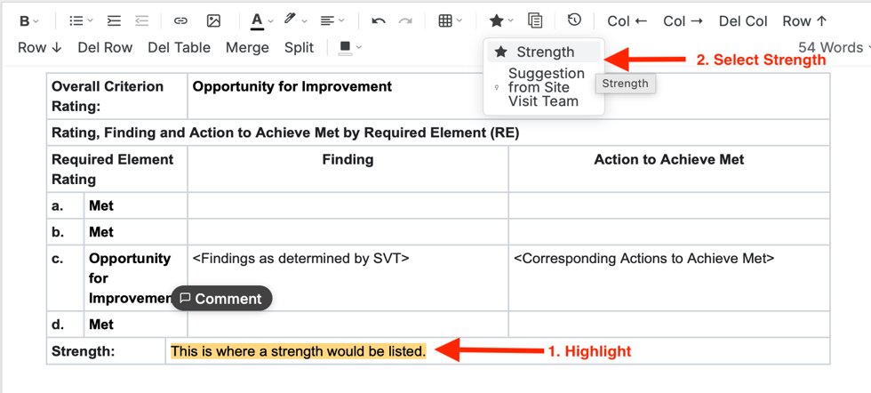
- Below the pasted table, enter any “Suggestions from the Site Visit Team”. Preface them with the header ‘Suggestion from Site Visit Team’. Highlight the suggestion and select the ‘Suggestion from Site Visit Team’.
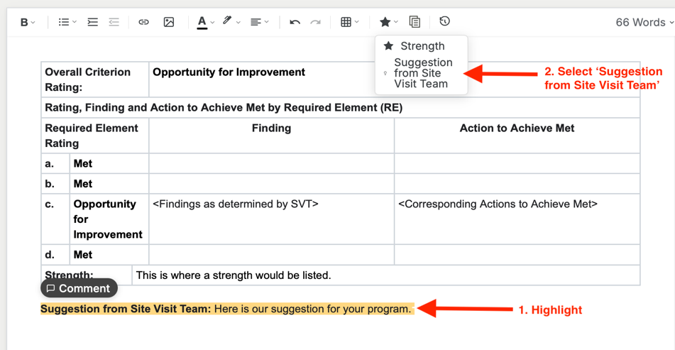
- Once all standards are reviewed, and report is entered, you must click the Submit to Accreditor button.
