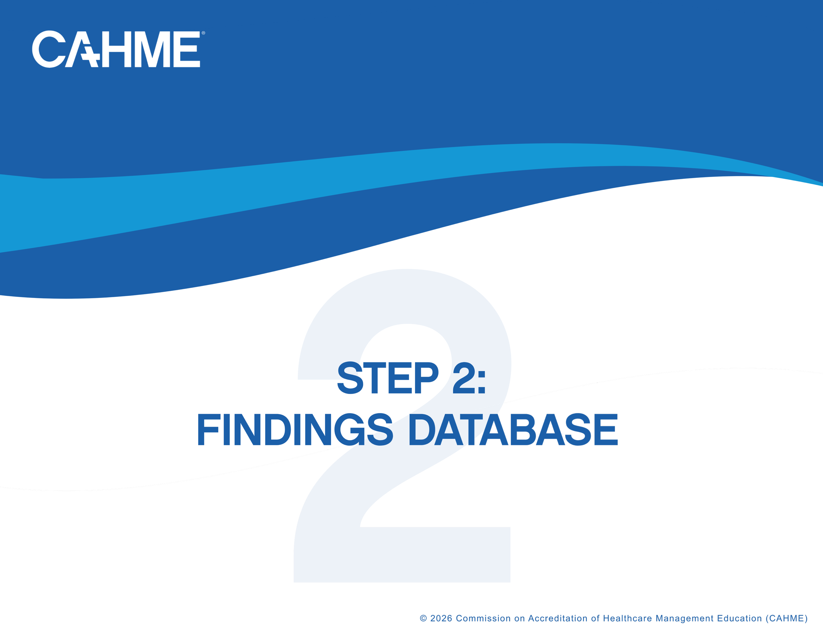

Revision History

Date | Section | Revision Details
7/23/2026 | All | First revision.

Findings Report Requirements

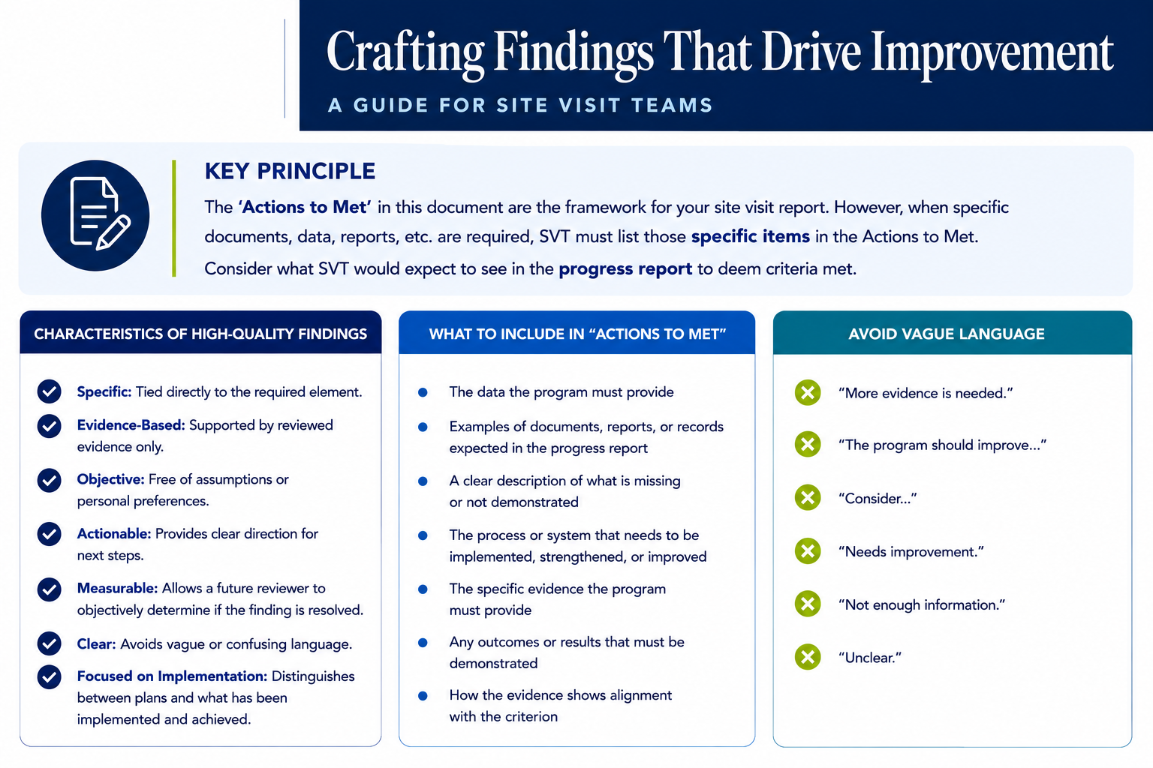

2.2 Competency Model Effectiveness
2.2.a | Opportunity for Improvement
2.2.a |  | Finding | Action to Achieve Met
2.2.a | ☐ | Aggregate program-level attainment data is provided but does not include all competencies for the self-study year. | Provide aggregate program-level attainment data for every competency for the self-study year.
2.2.a | ☐ | Aggregate program-level attainment data is provided but does not clearly show the level of student achievement for one or more competencies. | Report the level of student achievement for each competency using the program’s proficiency scale.
2.2.a | ☐ | Aggregate program-level attainment data is provided but does not report attainment across the proficiency levels used by the program. | Show attainment across the proficiency levels used by the program.
2.2.a | ☐ | Program-level targets are not clearly identified for each competency. | Identify the program-level target for each competency.
2.2.a | ☐ | Program-level outcomes do not clearly indicate whether the target was met or not met for each competency. | Indicate whether the target was met or not met for each competency.
2.2.a | ☐ | Other: | Other:
2.2.a | Critical Concern
2.2.a |  | Finding | Action to Achieve Met
2.2.a | ☐ | No aggregate program-level attainment data is provided for the self-study year. | Develop and submit aggregate program-level attainment data for all competencies for the self-study year.
2.2.a | ☐ | The program does not measure student competency attainment at the program level. | Measure student competency attainment at the program level for every competency.
2.2.a | ☐ | Exhibit 2.2.1 is missing or does not provide usable program-level competency attainment information. | Complete Exhibit 2.2.1 with usable program-level attainment information, including targets and outcomes.
2.2.a | ☐ | Other: | Other:
2.2.b | Opportunity for Improvement
2.2.b |  | Finding | Action to Achieve Met
2.2.b | ☐ | Direct competency-based measurement tools are provided but are not clearly aligned to the competencies they are intended to assess. | Align each direct competency-based measurement tool to the specific competency or competencies it assesses.
2.2.b | ☐ | Direct competency-based measurement tools are provided but are not clearly aligned to the program’s proficiency levels. | Align each direct measurement tool to the program’s defined proficiency levels.
2.2.b | ☐ | Direct measurement tools are provided but the evaluation criteria within the tools are unclear or incomplete. | Revise the tools so the evaluation criteria are clear and complete.
2.2.b | ☐ | Other: | Other:
2.2.b | Critical Concern
2.2.b |  | Finding | Action to Achieve Met
2.2.b | ☐ | No blank competency-based direct measurement tools are provided. | Develop and submit direct competency-based measurement tools used to assess program-level competency attainment.
2.2.b | ☐ | Other: | Other:
2.2.c | Opportunity for Improvement
2.2.c |  | Finding | Action to Achieve Met
2.2.c | ☐ | Indirect competency-based measurement tools are provided but are not clearly aligned to competency outcomes. | Align each indirect competency-based measurement tool to the competency outcomes it is intended to inform.
2.2.c | ☐ | Indirect competency-based measurement tools are provided but the relationship between the tools and competency outcomes is unclear. | Clarify the relationship between each indirect tool and the competency outcomes.
2.2.c | ☐ | Other: | Other:
2.2.c | Critical Concern
2.2.c |  | Finding | Action to Achieve Met
2.2.c | ☐ | No blank competency-based indirect measurement tools are provided. | Develop and submit indirect competency-based measurement tools used to assess program-level competency attainment.
2.2.c | ☐ | Other: | Other:

